**Create table:**

create table SBM_analytic_employee

(

employee_id number,

first_name varchar2(20),

last_name varchar2(20),

email varchar2(20),

phone_number varchar2(15),

hire_date date,

job_code varchar2(10),

salary number(5),

comm_pct number,

manager_id number,

department_id number

)

/

**Insert records:**

BEGIN

insert into SBM_analytic_employee values (100,'Steven','King','SKING','515.123.4567','01-JUN-2003','AD_PRES',24000,null,null,90);

insert into SBM_analytic_employee values (101,'Neena','Kochhar','NKOCHHAR','515.123.4568','21-SEP-2005','AD_VP',17000,null,100,90);

insert into SBM_analytic_employee values (102,'Lex','Dehaan','LDEHAAN','515.123.4569','13-JUN-2001','AD_VP',17000,null,100,90);

insert into SBM_analytic_employee values (103,'Alexander','Hunold','AHUNOLD','590.423.4567','03-JUN-2006','IT_PROG',9000,null,102,60);

insert into SBM_analytic_employee values (104,'Bruce','Ernst','BERNST','590.423.4568','21-MAY-2011','IT_PROG',6000,null,103,60);

insert into SBM_analytic_employee values (105,'David','Austin','DAUSTIN','590.423.4569','25-JUN-2005','IT_PROG',4500,null,103,60);

insert into SBM_analytic_employee values (106,'Valli','Petaballa','VPETABALLA','590.423.4570','05-FEB-2006','IT_PROG',4800,null,103,60);

insert into SBM_analytic_employee values (107,'Diana','Lorentz','DLORENTZ','590.423.4567','07-FEB-2002','IT_PROG',4200,null,103,60);

insert into SBM_analytic_employee values (108,'Nancy','Greenberg','NGREENBERG','515.124.4569','17-AUG-2002','FT_ACCOUNT',4800,null,101,100);

insert into SBM_analytic_employee values (109,'Daniel','Faviet','DFAVIET','515.124.4569','17-AUG-2002','FT_ACCOUNT',9000,null,108,100);

END;

/

**Select:**

select * from SBM_analytic_employee

/

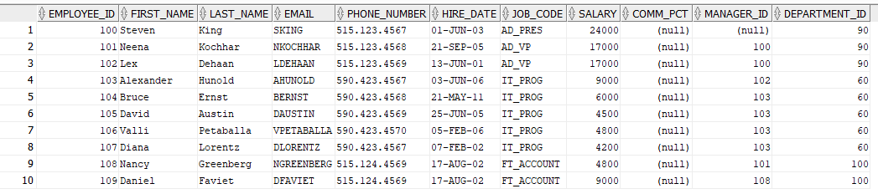

RANK()

***-- To find employee salary ranking from lowest to highest salary***

select employee_id, first_name, salary, department_id,

RANK () over (order by salary) as sal_wise_rank

from SBM_analytic_employee

/

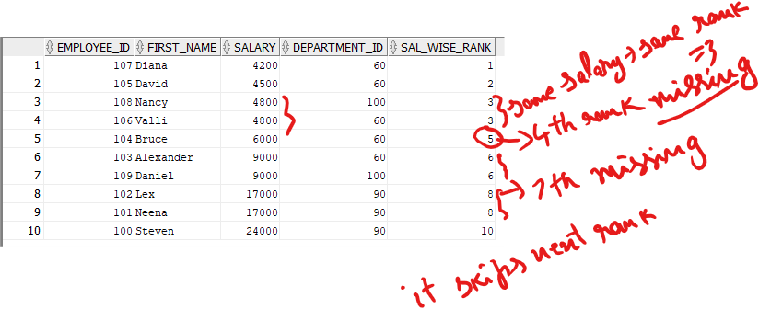

select employee_id, first_name, salary, department_id,

RANK () over (order by salary desc) as sal_wise_rank

from SBM_analytic_employee

/

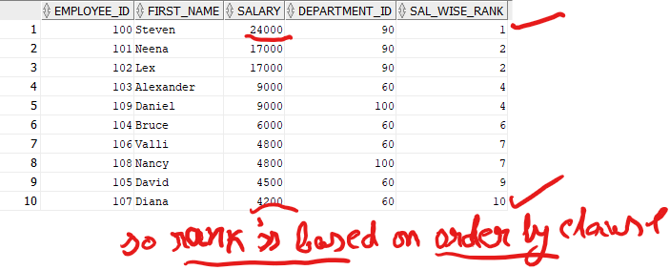

**Insert duplicate record two times**

insert into SBM_analytic_employee values (100,'Steven','King','SKING','515.123.4567','01-JUN-2003','AD_PRES',24000,null,null,90);

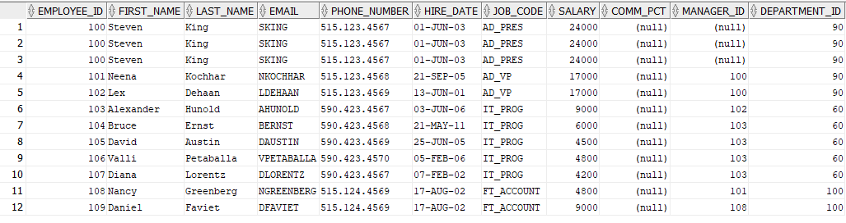

**Use RANK() to find duplicates**

select employee_id, first_name, salary, department_id,

rowid, RANK () over (partition by employee_id order by rowid) as sal_wise_rank

from SBM_analytic_employee

**/**

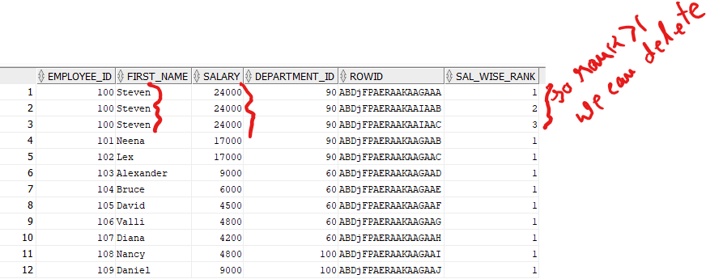

**DENSE_RANK()**

select employee_id,first_name,salary,department_id,

DENSE_RANK () over ( order by salary) as sal_wise_rank

from SBM_analytic_employee

/

